

**Bangladesh University of Business and Technology**

**Dept. name : Computer Science and Engineering Course name : Software Development Project Course code : CSE - 100**

**Project title : Hangman Guessing Game With C++**

**Intake** **51**

**Section** **06**

**Group no** **03**

**Submitted To :Khan Md. Hasib Assistant Professor, Department of CSE,BUBT**

**Submitted By :**

| **Shariar Soton** | **22235103105** |
| --- | --- |
| **Minhajur Rahman** | **22235103129** |
| **Omar Faruk Fahim** | **22235103132** |
| **Torikul Islam Lipon** | **22235103255** |
| **Utsob** | **22235103256** |

# Declaration

**We would like to state that the discussion titled “Hangman Guessing Game With C++ ” that we have submitted**

**for the course of Software Development 100, Department of CSE, a project work that we have completed under the supervision of Khan Md. Hasib and has not been given anywhere else. We will be held accountable if any errors are discovered.**

**Date: 09-11-2023**

# Acknowledgement

**We did everything we could to ﬁnish this project. We are new to this because it is our ﬁrst software development project.**

**However,We Omar Faruk Fahim, Minhajur Rahman , Shariar Soton, Utsob, Md Torikul Islam Lipon were able to complete our project. We made every effort to overcome our flaws.**

**Also, thanks to our honorable teacher, Khan Md. Hasib, for his guidance. His advice helped us in overcoming our flaws and mistakes.**

**Abstract**

**The Hangman Game Project addresses the need for entertaining and educational games, providing a user-friendly and interactive gaming experience for a diverse audience. This project introduces the classic game of Hangman in a digital format, designed to expand vocabulary and enhance language skills. The game's objectives encompass vocabulary enrichment, educational value, and accessibility for children, adults, and educators.**

**Key features of the Hangman Game include a wide range of word categories, a hint system for assistance, progress tracking, and an intuitive user interface. The game offers cognitive beneﬁts by promoting critical thinking,**

**problem-solving skills, and language development.**

# Table of Contents







## Project aim and objectives :

**The aim of the Hangman Game Project is to develop an entertaining and educational digital game that enhances vocabulary and language skills while oIering an enjoyable gaming experience. This project targets a diverse user panel, including children, adults, and educators, with the goal of providing a valuable tool for language learning and cognitive development.**

## Development Environment :

**Our development environment for the Hangman Guessing Game is shown below:**

|  | **Intel i5 11th Gen** |
| --- | --- |
|  |  |
|  | 8GB DDR 4 |
|  | GB |
|  |  |
|  |  |



## General Description :

**The Hangman Game, a classic word-guessing pastime, has found a new digital identity in this inventive project. Inspired by the age-old game's ability to make learning fun, the Hangman Game has been reimagined for the digital age. It blends entertainment with education to create a versatile tool for expanding vocabulary and language skills.**

**The Hangman Game brings together the joy of gaming and the beneﬁts of education. It's a versatile digital tool that promotes vocabulary expansion, language development, and cognitive growth. Its adaptability for different age groups and ease of integration into education make it a valuable asset in the digital world of learning and leisure**.



## Software Design:

**This is software design for our Hangman Guessing Game Project:**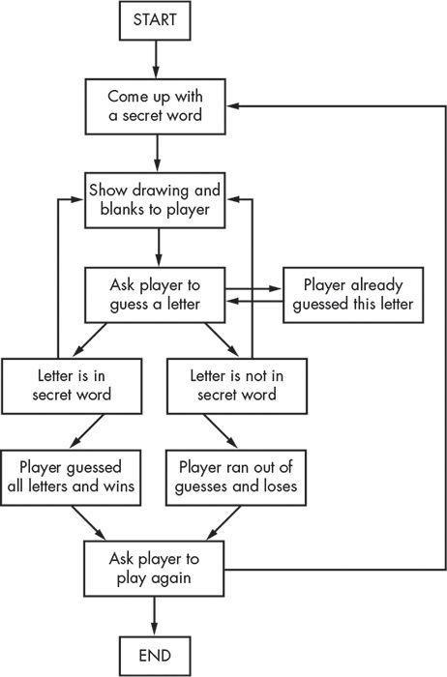

## Implementation:

**Launch the Game:**

**Module Description**

Start by launching the Hangman game on your computer or device.

**Choose a Category:**

The game will prompt you to choose a word category. You can select from a variety of categories, such as animals, fruits, or countries.

**Guess the Word:**

The game will then present you with an empty word, represented by underscores. Your task is to guess the word by suggesting letters.

**Make a Guess:**

Enter a letter you think is in the word. The game will check if the letter is part of the word.

**Correct Guess:**

If your guess is correct, the game will reveal all occurrences of the letter in the word, and you can continue guessing until you complete the word.

**Incorrect Guess:**

If your guess is incorrect, the game will deduct one of your attempts, and a part of the hangman graphic will be displayed.

**Hint Option:**

If you need help, you can choose to use one of your hints. The game will reveal one letter of the word to assist you.

**Progress Tracking:**

The game keeps track of your attempts and may show your progress in the form of a partially completed hangman drawing.

**Win or Lose:**

Continue guessing letters until you either successfully guess the word or run out of attempts. If you guess the word, you win, and the game congratulates you. If you run out of attempts, the game displays the solution.

**Play Again:**

You can choose to play again, select a diIerent word category, or quit the game.

## Features :

These are some important feature for our software:

* Word Categories: A wide selection of word categories, including animals,fruits, countries, and more.
* Players can store their achievements.
* Hint System: Players can request hints to assist them in guessing the word.
* Progress Tracking: The game will monitor player progress, displaying statistics and achievements.
* Educational Value: The game is designed to improve vocabulary and language skills, making it an excellent tool for language learners and educators.
* User-Friendly Interface: An intuitive and appealing user interface for a seamless gaming experience.
* Sound Libraries: Utilize sound libraries for sound eIects and feedback.
* This game is designed to be user-friendly for kids and oIers an entertaining way to expand their vocabulary and language skills.
* Adults can also enjoy the game, either on their own or with their children. It’s a great way to unwind while keeping their minds sharp.
* Teachers can incorporate the game into their lessons to make learning more engaging and interactive.



## User Interface :

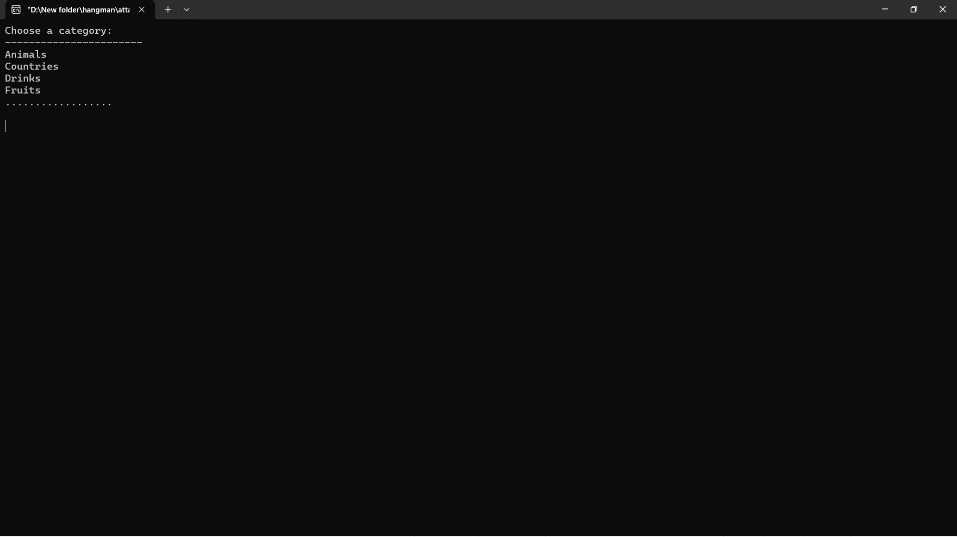

**Launch the Game:**

**Choose a Category:**

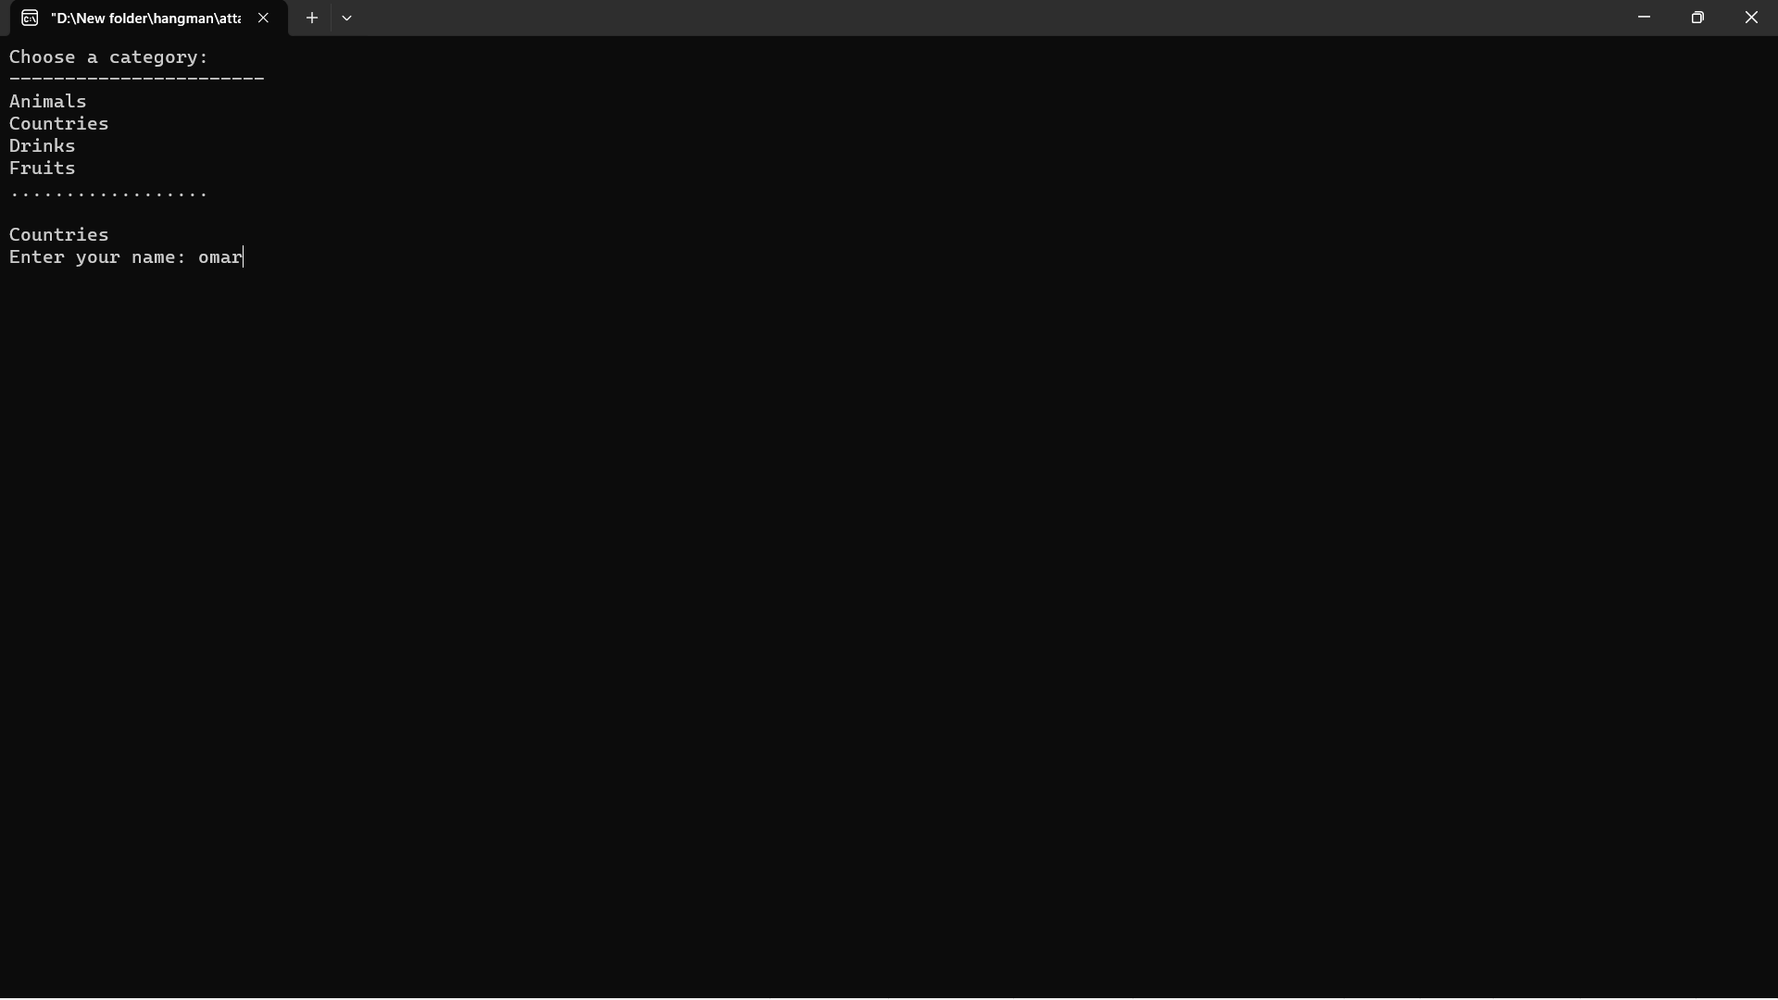

**Make a Guess:**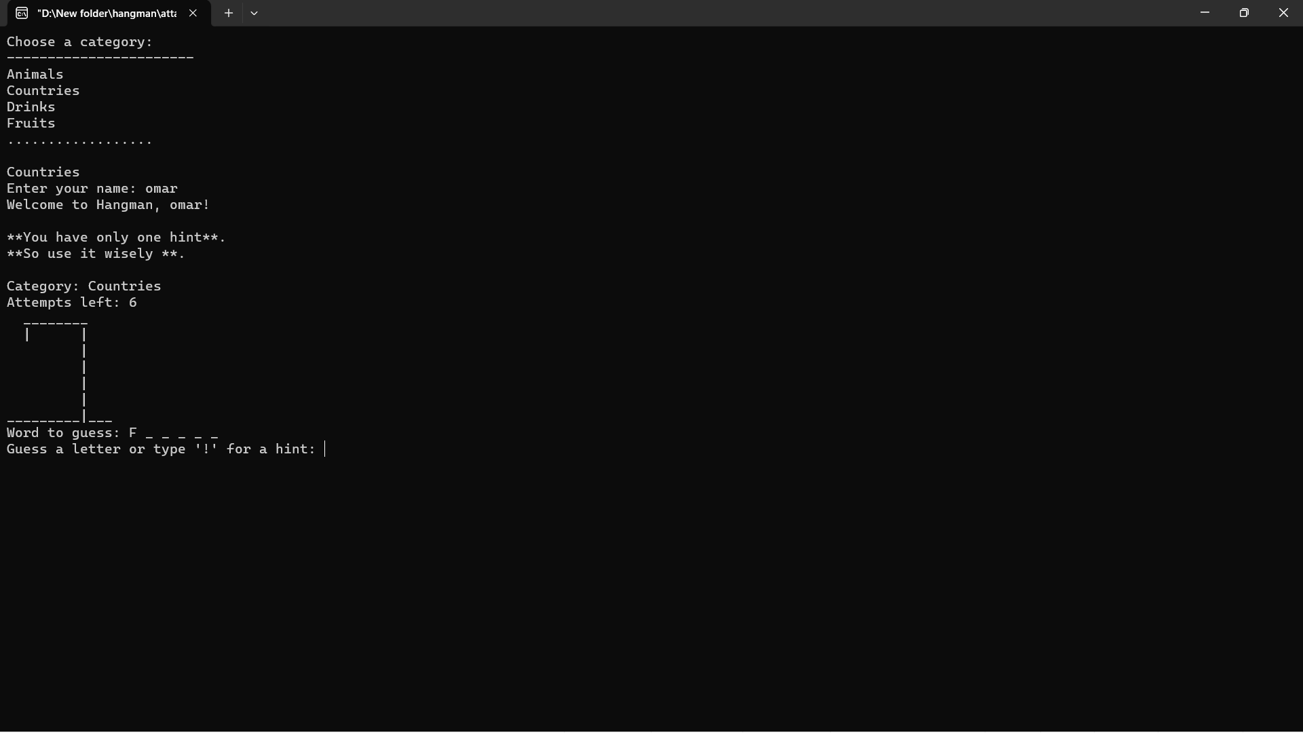

**Hint Option:**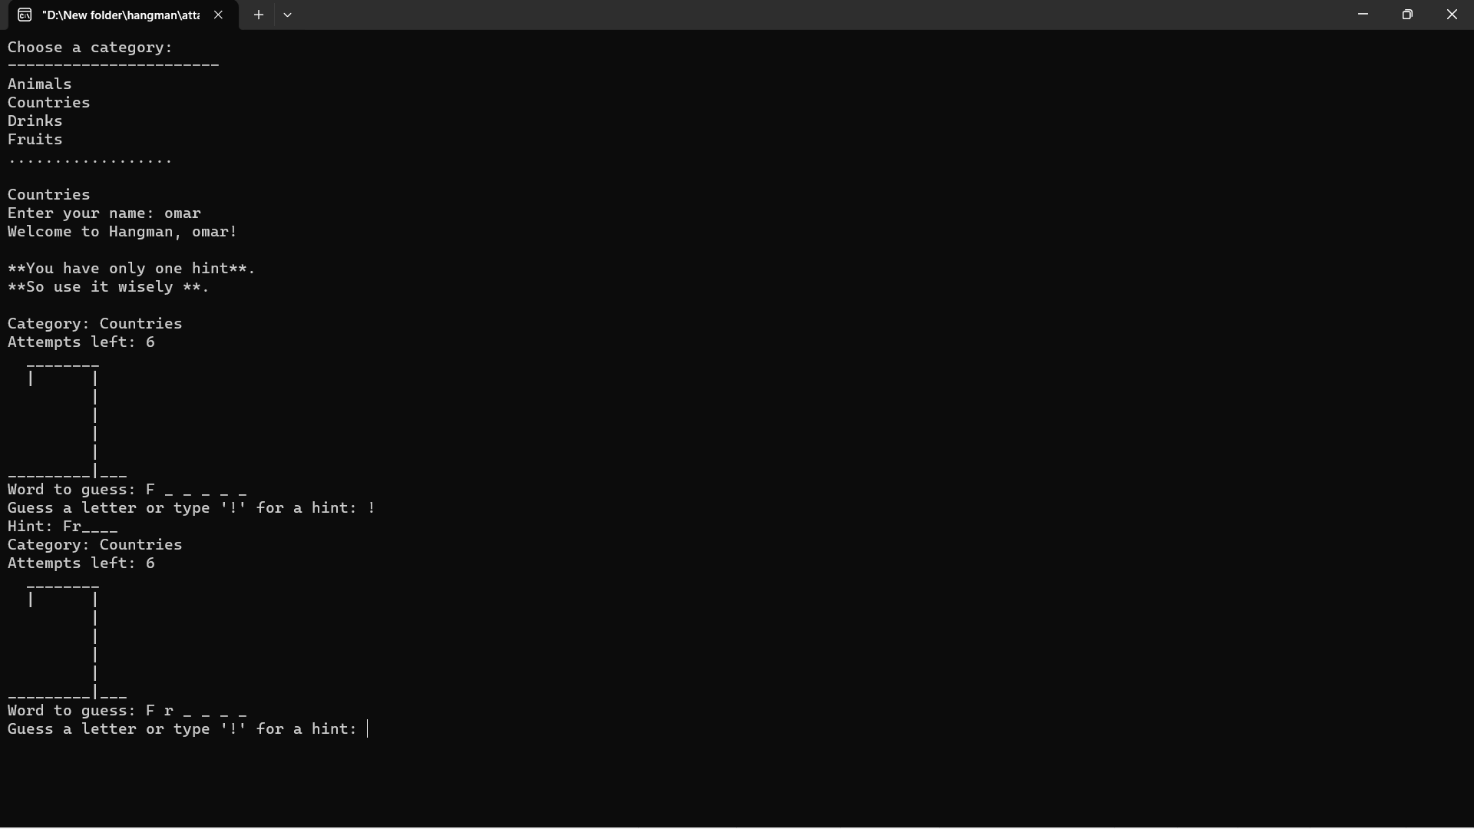

**Correct Guess:**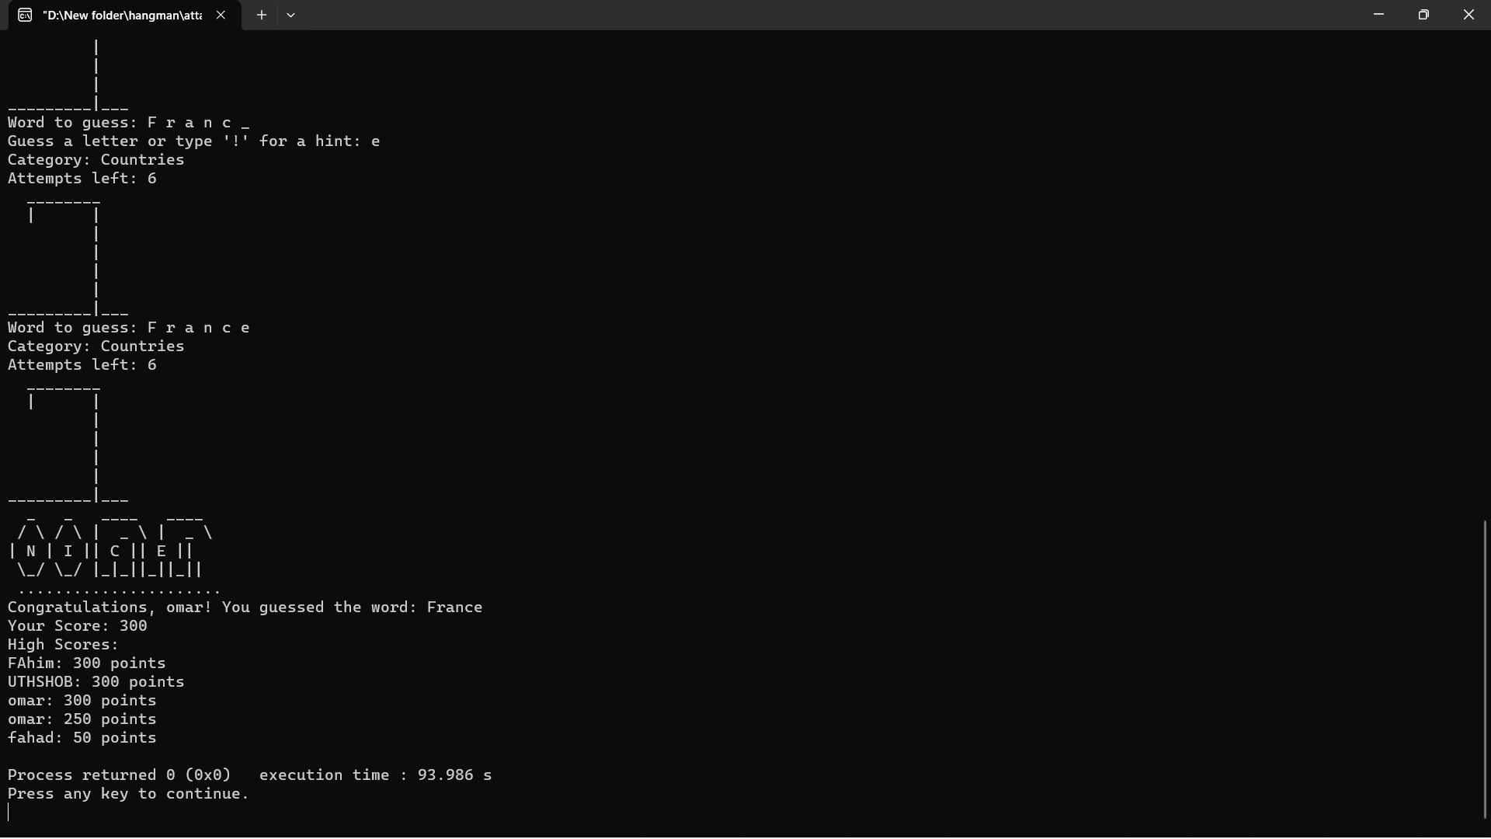

**Incorrect Guess:**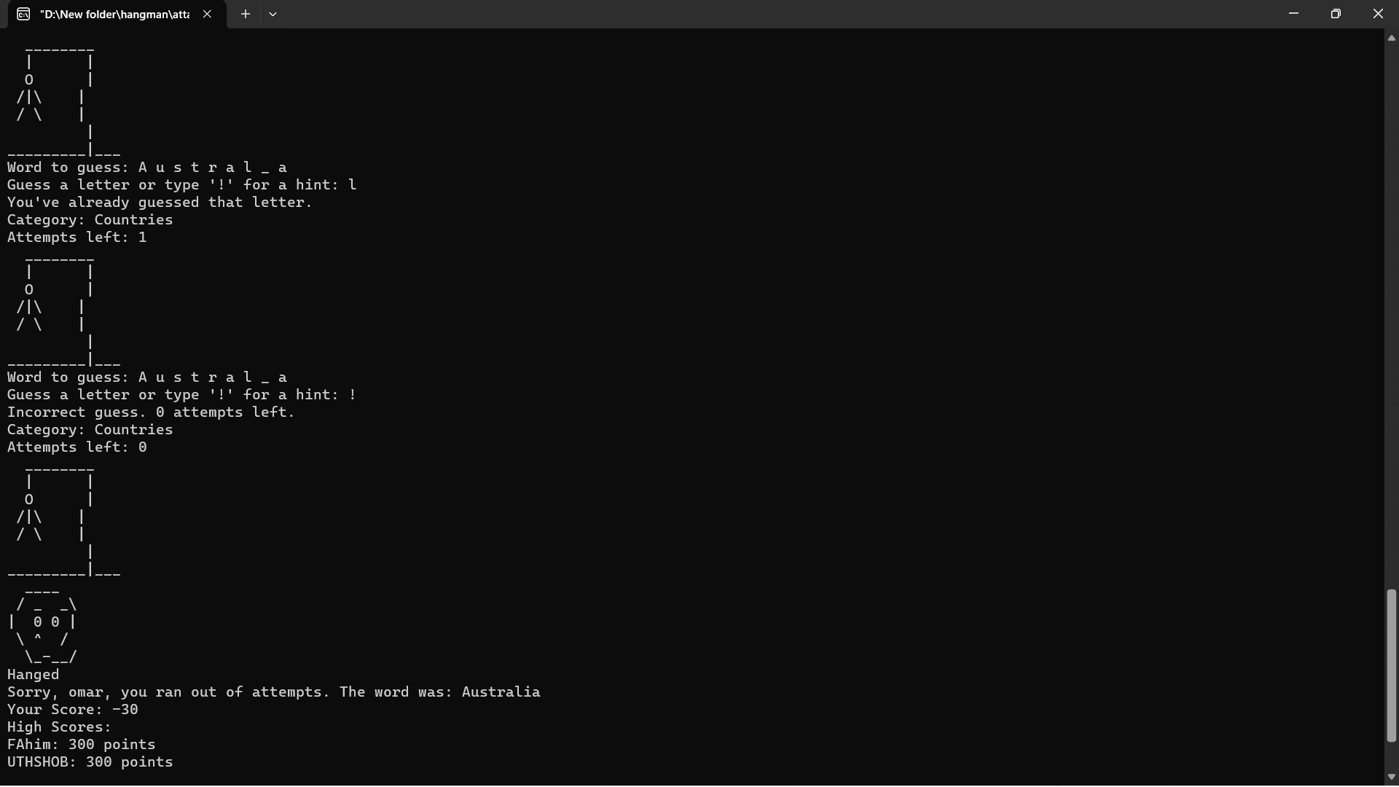

**Win or Lose:**



## Future work and conclusion :

The Hangman Game project presents various avenues for future work and improvements to enhance its functionality and reach. Some potential directions for future development include:

1. Platform Compatibility: Expanding the project to be accessible on various platforms, such as mobile devices and web browsers, to cater to a broader audience.
2. Graphical Enhancements: Improving the game's graphics, animations, and overall visual appeal to provide a more immersive gaming experience.
3. Online Multiplayer: Implementing an online multiplayer mode to allow players from diIerent locations to compete or collaborate in real-time.

**y**. Additional Word Categories: Expanding the word database with more categories to diversify the game's content and challenge.

**5**. Enhanced Educational Features: Incorporating more educational elements, such as providing word meanings, synonyms, and example sentences to further aid language learning.

**5**. Leaderboards and Achievements: Adding a competitive edge to the game by introducing leaderboards and achievements that motivate players to excel and return for more gameplay.

**7**. Localization: Translating the game into multiple languages to make it accessible to a global audience and foster language learning in diIerent regions.

**V**. Accessibility Features: Ensuring the game is accessible to individuals with disabilities by implementing features like screen readers and keyboard navigation.

## Conclusion:

The Hangman Game project represents a creative blend of entertainment and education, providing users of all ages with an enjoyable and enriching gaming experience. The game not only expands vocabulary and language skills but also fosters cognitive development and social interaction. Its adaptability for children, adults, and educators makes it a versatile tool for both learning and leisure.

In conclusion, the Hangman Game oIers a platform for personal growth and entertainment, uniting the joy of gaming with the beneﬁts of language development. With potential future expansions and enhancements, it can continue to be a valuable addition to the world of digital games and education.

## References :

⧫⧫Tutorials

⧫⧫ Google